**Student Name and Section Number: Jermaine Merritt ACA122-B220**

**Date:2/24/2025**

Exercise 6A | Your Academic and Transfer Plan

Your Academic and Transfer plan will outline the requirements for admission to your university as well as identify the academic requirements and classes you will need for your community college and your university degree.

1. **List the name of your university choice and include the website you used to research the answers below:** University Of North Carolina at Charlotte
2. **Are you applying as a transfer student or first year student:** Transfer student

|  |  |
| --- | --- |
| Requirements | Answers |
| 1. Name your major and degree (B.A. B.S. etc.) | My major is Business Administration |
| 1. What is the Application deadline and fee? | The application deadline is November 15,  2025 for spring 2026. The application fee is $75. |
| 1. What is the GPA requirement for the university? | The GPA requirement for the university is 2.5. |
| 1. List any specific GPA or other academic requirements specific to my major (list GPA and other academic requirements if your program is competitive) | The specific GPA requirement for business administration is 2.5. There isn’t any academic requirement for transfer student in business administration. |
| 1. What are the minimum credits required for transfer to this university? | The minimum credit required for transfer to University of North Carolina at Charlotte is 2.5. |
| 1. Official transcripts–list what you need for the application. For example, do you need High School, College, etc.) | I will need my college official transcripts for my application. |
| 1. References/ recommendations–Is it required or not? | References or recommendations is not required for transfer student in my degree at University of North Carolina at Charlotte. |
| 1. Test scores–Are they required or not? | Test scores are not required for transfer student. |
| 1. Admission essay– Is it required or not? | Admission essay is not required for transfer student. |

**Part 2 | Academic Plan**

1. **In which Central Piedmont associate degree are you enrolled? List your degree and share the** [**link to the course sequence from the Central Piedmont catalog**.](https://catalog.cpcc.edu/programs/college-level/) This includes students in the Middle Colleges or Early College as you are enrolled in an associate degree also.

NOTE: If you are a College and Career Promise Student not in the Middle Colleges or Early College, [please attach the Transfer Pathway you are working toward.](https://www.cpcc.edu/programs/dual-enrollment/pathway-details-dual-enrollment)

1. **Associate degree You are enrolled in at Central Piedmont**

Associate in arts (A.A.) Degree (10100)

1. **Course Sequence Link**

[College Transfer Associate in Arts (A.A.) Degree | Central Piedmont](https://catalog.cpcc.edu/programs/college-level/college-transfer/associate-in-art/)

1. **Share the link to the Transfer Guide from the NC university you will attend.**

[You can visit the CFNC page for the Transfer Guides OR visit your NC public University’s website.](https://www.cfnc.org/plan-your-future/plan-for-college/transfer-student-planner/to-unc-system-institutions/transfer-guides/) If you are going to a private university in NC or to an out of state university, share the link to your degree at that university or a course plan if they have one.

1. **Transfer Guide link**

[Program: Business Administration, B.S.B.A. - University of North Carolina at Charlotte - Modern Campus Catalog™](https://catalog.charlotte.edu/preview_program.php?catoid=38&poid=11427)

1. **Now plan out the next 4 semesters of your associate degree for Central Piedmont (including the current one). What classes will you take each semester?**

**Create a semester-by-semester plan on the next page of how you will work to complete your associate degree.** [**You will use your Course Sequence from the catalog to help plan out your courses**](https://catalog.cpcc.edu/programs/college-level/)**.** Be sure to include any prerequisites you need to take for your bachelor’s degree/major. You can find this information in the transfer guide for your university.

**Tips for completion**

1. **If this is your last semester**, please list the current semester of classes AND some of the the classes you might take the first semester at the university. Use your transfer guide to complete this.
2. **If you are not completing your associate degree** **before you transfer**, please list the 24 or 30 credits you need for the minimum transfer to your university.
3. **If you are dual enrolled and planning to take classes** **until you graduate high school** but will NOT complete the associate degree, list all the Central Piedmont college classes you plan to take.

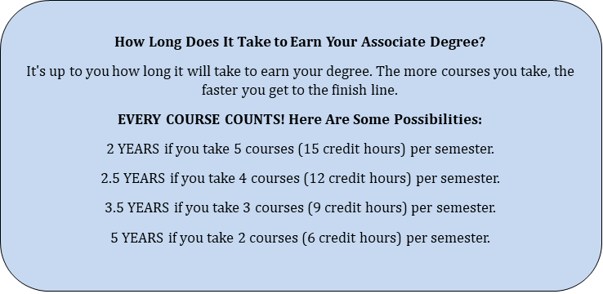

**Semester 1: Be sure to list the course and Number, such as ENG 111 or Mat 171.**

**NOTE: Start with your current semester here. Spring 2025**

|  |  |
| --- | --- |
| Course Requirement | Credits |
| ACA 122-B220 | 1 |
| BIO 110-B1101 | 4 |
| HUM 130-B203 | 3 |
| BUS 110-B221 | 3 |
| COM 231-B220 | 3 |
| ECO 251-B200 | 3 |
| Total credit hours this semester: | 17 |

**Semester 2: List Fall, Spring or Summer and Year Summer 2025**

|  |  |
| --- | --- |
| Course Requirement | Credits |
| ACC120 | 4 |
| CIS110 | 3 |
| ECO252 | 3 |
|  |  |
|  |  |
| Total credit hours this semester: | 10 |

**Semester 3: List Fall, Spring or Summer and Year Fall 2025**

|  |  |
| --- | --- |
| Course Requirement | Credits |
| ART 111 | 3 |
| MAT 152 | 4 |
|  |  |
|  |  |
|  |  |
| Total credit hours this semester: | 7 |

**Semester 4: List Fall, Spring or Summer and Year**

|  |  |
| --- | --- |
| Course Requirement | Credits |
|  |  |
|  |  |
|  |  |
|  |  |
|  |  |
| Total credit hours this semester: |  |

1. **State your plans/timeline for completion of your associate degree and transfer. How many years will it take you to complete your associate degree or get ready to transfer?**
   * + Are you planning to transfer before completing your associate degree? If so, state when you plan to transfer (semester and year).

My plans for completion of my associate degree and transfer is fall 2025. It will take me one year to complete my associate degree and get ready to transfer.

* + - If you are staying to complete your associate degree, please state your graduation date (semester and year).

I will complete my associate degree and graduate in December 2025.

**Part 3 | Transfer and Academic Plan Task List**

What questions do you have about your transfer/academic plan? **Create a to do list of things you still need to research/tasks you need to complete. You should have at least 2 tasks on your list.**

For example: Meet with an advisor to discuss my classes for next semester OR contact NC State to ask about the GPA needed to be competitive for Engineering.

|  |  |
| --- | --- |
| Actions | Target Date |
| 1. I will complete my application and pay my $75 fee. | August 1, 2025. |
| 2. I will meet with my advisor to pick my classes for spring semester 2026. | December 1, 2025. |
| 3. |  |